Neural Network–Based Credit Risk Prediction Using a Multi-Layer Perceptron (MLP)
Assignment 1

Course: Deep Learning Architectures and Techniques Name: Saksham Semwal
Roll No: 2501940031
Faculty: Dr. Shahid Ahmad Wani



Department of Computer Science and Engineering School of Engineering and Technology
K.R Mangalam University, Gurugram- 122001, India

Dataset Description

The German Credit Dataset is used in this experiment to perform binary classification for credit risk prediction. The dataset contains 1000 customer records with multiple financial and personal attributes. The objective is to classify customers into two categories: good credit risk and bad credit risk.
The dataset originally consists of 20 input features describing financial history, loan details, employment status, age, and other related attributes. The target variable indicates whether a customer is creditworthy (good) or not creditworthy (bad).

Data Preprocessing

Before training the neural network model, several preprocessing steps were performed to prepare the dataset:

Missing Value Handling:
The dataset was checked for missing values using Pandas functions. No missing values were found in any feature.

Target Encoding:
The target variable originally contained categorical values ('good' and 'bad'). These were converted into numerical format where good = 1 and bad = 0 to make the data suitable for binary classification.

Categorical Feature Encoding:
Several input features were categorical in nature. These were converted into numerical form using one-hot encoding with the pd.get_dummies() function.

Feature Scaling:
All numerical features were standardized using the StandardScaler technique. This ensures that the features have zero mean and unit variance, which helps improve neural network training stability and performance.

Train-Test Split:
The dataset was divided into 80% training data and 20% testing data using train_test_split with a fixed random seed for reproducibility.

Model Architecture

A Multi-Layer Perceptron (MLP) model was designed to perform binary classification on the credit risk dataset. A feedforward neural network architecture was implemented using TensorFlow/Keras.
The architecture of the model is as follows:

Input Layer:
The input layer consists of 48 features obtained after one-hot encoding and preprocessing.

Hidden Layer 1:
The first hidden layer contains 64 neurons with ReLU activation function. ReLU introduces non-linearity and helps the network learn complex patterns.

Hidden Layer 2:
The second hidden layer consists of 32 neurons with ReLU activation. This layer further refines feature representations learned from the previous layer.

Output Layer:
The output layer contains 1 neuron with Sigmoid activation function. The sigmoid function produces output values between 0 and 1, representing the probability of a customer being a good credit risk.

Loss Function:
Binary Cross-Entropy loss was used, as it is suitable for binary classification problems.

Optimizer:
The Adam optimizer was used to update the network weights efficiently during training.

Training Results and Visualization

The model was trained for 50 epochs using a batch size of 32 and a validation split of 20% from the training data. During training, both training loss and validation loss were monitored. Similarly, training accuracy and validation accuracy were recorded at each epoch.
The training accuracy gradually increased and eventually reached nearly 100%, while the validation accuracy stabilized around 73%. The validation loss increased after several epochs, indicating that the model started overfitting the training data.
The following plots show the training and validation loss curves, as well as training and validation accuracy curves.

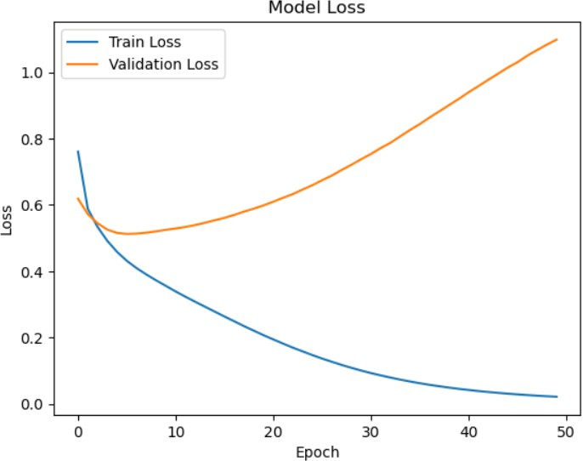
Figure 1: Training and Validation Loss Curve

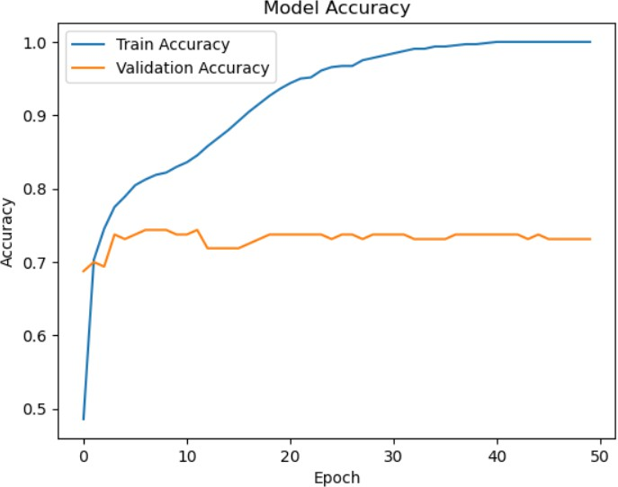
Figure 2: Training and Validation Accuracy Curve

Model Evaluation and Discussion

The trained model was evaluated on the unseen test dataset (20% of total data).
The model achieved a test accuracy of approximately 72%, indicating that it correctly classified most of the credit risk instances.

Classification Metrics:

For class 0 (Bad Credit):
- Precision: 0.53
- Recall: 0.54
- F1-score: 0.54

For class 1 (Good Credit):
- Precision: 0.81
- Recall: 0.80
- F1-score: 0.80

The confusion matrix further illustrates that the model performs better in identifying good credit customers compared to bad credit customers.

Discussion:

Although the training accuracy reached nearly 100%, the validation and test accuracy remained around 72–73%. This indicates that the model suffers from overfitting. The model has learned the training data very well but does not generalize equally well to unseen data.
Overfitting may be due to the limited dataset size (1000 samples) and the relatively powerful neural network architecture. Regularization techniques such as Dropout, L2 regularization, or reducing the number of neurons could potentially improve generalization performance.

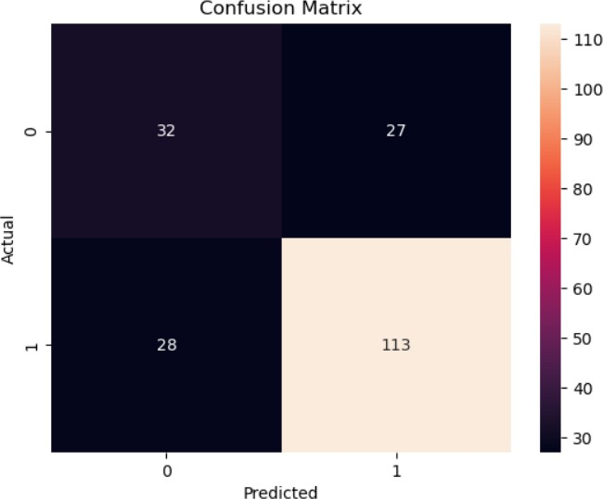

Figure 3: Confusion Matrix for Test Data

Conclusion
In this experiment, a Multi-Layer Perceptron (MLP) was successfully implemented for credit risk prediction using the German Credit Dataset. The model achieved a test accuracy of approximately 72%. The results demonstrate that neural networks can effectively perform binary classification on structured financial data.
However, the model exhibited signs of overfitting, as training accuracy was significantly higher than validation and test accuracy. Future improvements may include applying regularization techniques, reducing model complexity, or using more advanced architectures to enhance generalization performance.

